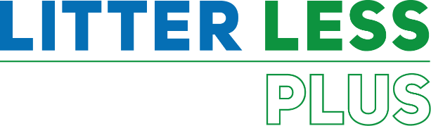

GUIDELINES
FOR CREATING
A LESSON PLAN
#litterlessplus

This document provides teachers with guidelines on developing a lesson plan on the subject of pollution. To improve your chances of winning the Litter Less Plus Competition, please fill-in as many details as possible and bear in mind that your lesson plan needs to address one or more of the following topics:
  - Reduction of litter and waste
  - Promotion of responsible production and consumption
  - Increasing knowledge and taking actions to reduce invisible pollutants
  - Promotion of the circular economy model

We thank you in advance for your participation and will do our best to share it with our network.
- Foundation for Environmental Education

- AUTHOR DETAILS

- Name/s
- Country
- Institution/School
- Email
- Programmes the school is participating in (Eco-Schools/LEAF/YRE/other)
- Would you like to receive monthly updates through our Newsletter? Yes/No
- Submission date (dd/mm/yyyy)

- THE LESSON PLAN

- Theme – The title of the lesson

- Introduction – A brief description of what the lesson is about. (100 words max.)

- Age Group – Age group that it is suitable for (e.g. Age 6 to 9, Age 10 to 11, etc.)

- Objectives or Learning Outcomes – List 3-5 objectives/learning outcomes that you are expecting to achieve during the lesson.

- Time required to deliver the lesson plan – If more than one class session (30-45mins), please indicate the time required.

- Remote preparation - (if any) Anything that you (or the students) need to do BEFORE the lesson. (e.g. collect and bring to school 3 items labelled as hazardous)

- Planning considerations - (if any) such as (i) ‘warnings’ about misconceptions students might have about the lesson’s topic and how to deal with them; (ii) safety precautions; (iii) tips and other useful information

- Resources Required to deliver the lesson plan – Material, equipment and reading resources needed

- Activity – Steps or description of how the lesson will be conducted/facilitated by the teacher.

Structure your description using these main headings:
  - Introduction

  - Development

  - Conclusion

- Evaluation and Assessment – How will you check that the Objectives or Learning Outcomes (listed in D) were achieved?

- Dissemination – How will you communicate about the products of the lesson for awareness raising? If your lesson plan has already been implemented, attach a link of a product produced during the lesson (e.g., video, poster, presentation, URL link/website link).

- Follow-up activity - (if any) Suggest an activity that can build on what the students learned during your lesson

- Adaptations for students with learning difficulties – (if any)

- Extension for gifted students – (if any)

- Background information for teachers - Include any website links and resources that would provide teachers with useful information about the lesson’s topic

- References – Acknowledge the resources that were used while developing the Lesson Plan.

